**FIA1 Final**

**Introduction:**

The required task is to develop a function that models the shape of a waterspout from a water bubbler and to generate a detailed report explaining how to develop and refine the model. Multiple functions will be produced to explore the most accurate modelling of the water spout. These functions will be collated and referred to, to add more data sources to the report. One of the functions will be selected, validated, and justified by the coordinates collected from the parabola.

**Assumptions:**

It can be assumed that the camera was placed as perpendicular as possible to the waterspout when taking the photograph because it assists in not skewing the photo, creating more accurate coordinates. It can also be assumed that the camera was in focus and that the printer has a high-quality print because this affects the overall consistency of the graph and the plotting of the coordinates. It is also assumed that outside forces such as wind and varying water pressure will not affect the graph's dilation, turning point, and overall width, because they impact the accuracy of the quadratic function.

**Observations:**

It can be observed that each coordinate on the graph is spaced out evenly along the parabola of the waterspout because this correlates to the accuracy of the modelled function. It can also be observed that the dilation will be negative (a reflection) because the waterspout does not defy Newton’s laws of physics and will fall back to earth due to gravity (Britannica, 2019). It can also be observed that the dilation will be a fraction because the x value range is larger than the y value range creating a wide graph, and thus a fraction instead of a whole number. It can also be observed that the R2 value will never be 1 because it is practically impossible to achieve a perfect parabola where the trendline passes through all the points due to nature and the possibility of human error.

**Mathematical Translation:**

Throughout this task, it is required to use advanced mathematical formulas and concepts to calculate and refine the function and modelling inside of excel and desmos. After plotting all of the coordinates and retrieving the turning point (h,k) and the x-intercepts they are used to calculate the $a$ values (the dilations) using the turning point formula: $y=a{\left(x±h\right)}^{2}±k$ (*How to Find the Turning Point of a Parabola?*, 2022). The a-values will be negative values as the waterspouts follow the laws of gravity and will eventually fall downwards (Britannica, 2019). Both x-intercepts and higher power polynomials, $x^{3}$, $x^{4}$, $x^{5}$, $x^{6}$, will be used to calculate their respective formula to generate the highest possible valid R2 value (*X Intercept - Definition, Formula, How to Find, Examples*, n.d.). The R2 value is a range from 0 to 1 which determines the accuracy of a trendline to its coordinates with the latter being the most accurate (Nau, 2019). The R2 and multiple formulas assist in determining the validity of the solution as it compares multiple different parabolas on the task to calculate the best graph and formula.

**Solve:**

To begin the investigation the task was to locate, photograph, and print an appropriate waterspout considering the assumptions and observations. The final waterspout photograph that was chosen qualifies with the assumptions and the observations is displayed in Figure 1.

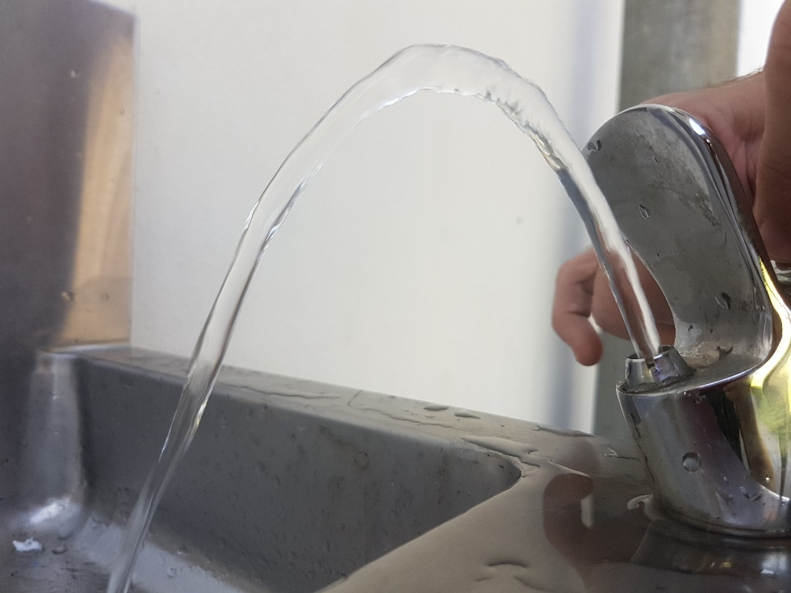**Figure 1**

Next task was to transcribe the waterspout data points onto the cartesian plane, ensuring that each coordinate was placed appropriately according to the original photograph.

The next task was to list out the coordinates so that they could be transferred into Microsoft Excel and Desmos for further development. The full list of coordinates are shown below in Figure 2.

**Figure 2**

|  |  |
| --- | --- |
| 0 | 0 |
| 1 | 1.5 |
| 1.5 | 3.5 |
| 2.5 | 5.5 |
| 3.5 | 7.5 |
| 4 | 9.5 |
| 5 | 11.5 |
| 5.5 | 13.5 |
| 6.5 | 15 |
| 7 | 17 |
| 7.5 | 18.5 |
| 8 | 20 |
| 9 | 23 |
| 10 | 24.5 |
| 11 | 27 |
| 12 | 29.5 |
| 13 | 32 |
| 14 | 34 |
| 15.5 | 35.5 |
| 16.5 | 37 |
| 18 | 39 |
| 19 | 40 |
| 20.5 | 41.5 |
| 22 | 43.5 |
| 24.5 | 45.5 |
| 26 | 46 |
| 27 | 47 |
| 29 | 47.5 |
| 30.5 | 47 |
| 32 | 46.5 |
| 34 | 45.5 |
| 35.5 | 44.5 |
| 37 | 42.5 |
| 38.5 | 41 |
| 39.5 | 39 |
| 41 | 37 |
| 42 | 35.5 |
| 43 | 34 |
| 43.5 | 32.5 |
| 44 | 31 |
| 45 | 29.5 |
| 45.5 | 28 |
| 46 | 26.5 |
| 46.5 | 25.5 |
| 47.5 | 23 |
| 48 | 22 |
| 48.5 | 20 |

The next task was to substitute the $x$-intercept into the turning point formula to find the $a$ value. The $x$-intercept being (0,0) and the (h,k) turning point value being (29,47.5) were calculated in Figure 3 below.

**Figure 3**

$$y=a{\left(x±h\right)}^{2}±k$$

$$0=a{\left(0-29\right)}^{2}+47.5$$

$$0=a\left(841\right)+47.5-47.5$$

$$-47.5=a(841)$$

$$\frac{-47.5}{841}=\frac{a(841)}{841}$$

$$\frac{-47.5}{841}=a$$

$$y=\frac{-47.5}{841}{\left(x-29\right)}^{2}+47.5$$

Figure 3 above shows that the $x$-intercept calculated an $a$ value of $\frac{-47.5}{841}$ in Figure 3 which matches our assumptions of being a reflection (negative).

Due to the way the values were transcribed from Figure 1 it is shown below in Figure 5 that there isn’t a 2nd $x$-intercept value in the list of values in Figure 2. Instead, the furthest value (48.5,20) was substituted into the turning point formula instead with the same (h,k) turning point (29,47.5) in Figure 4. This is because the aim is to find an appropriate equation that passes through the most coordinates.

**Figure 4**

$$y=A{\left(x±h\right)}^{2}±k$$

$$20=A{\left(48.5-29\right)}^{2}+47.5$$

$$20=A{\left(19.5\right)}^{2}+47.5-47.5$$

$$-27.5=A(380.25)$$

$$\frac{-27.5}{380.25}=\frac{A(380.25)}{380.25}$$

$$\frac{-27.5}{380.25}=A$$

$$y=\frac{-27.5}{380.25}{\left(x-29\right)}^{2}+47.5$$

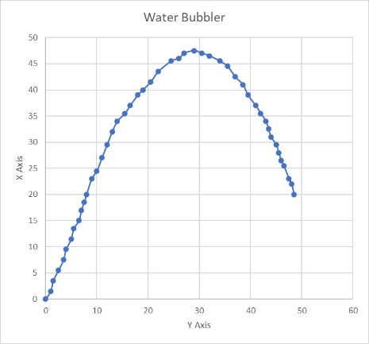**Figure 5**

As calculated in Figure 4 above the coordinate (48.5,20) has an $a$ value of $\frac{-27.5}{380.25}$ which also matches our assumptions of being a reflection (negative).

In Figure 6 below it is clearly shown that the formula in Figure 3 is not a valid solution as the parabola only goes through the $x$-intercept and the (h,k) point while missing every other coordinate. This can be attributed to the left $x$-intercept being the falling end of the water stream in Figure 1 to which is prone to natural abnormalities.

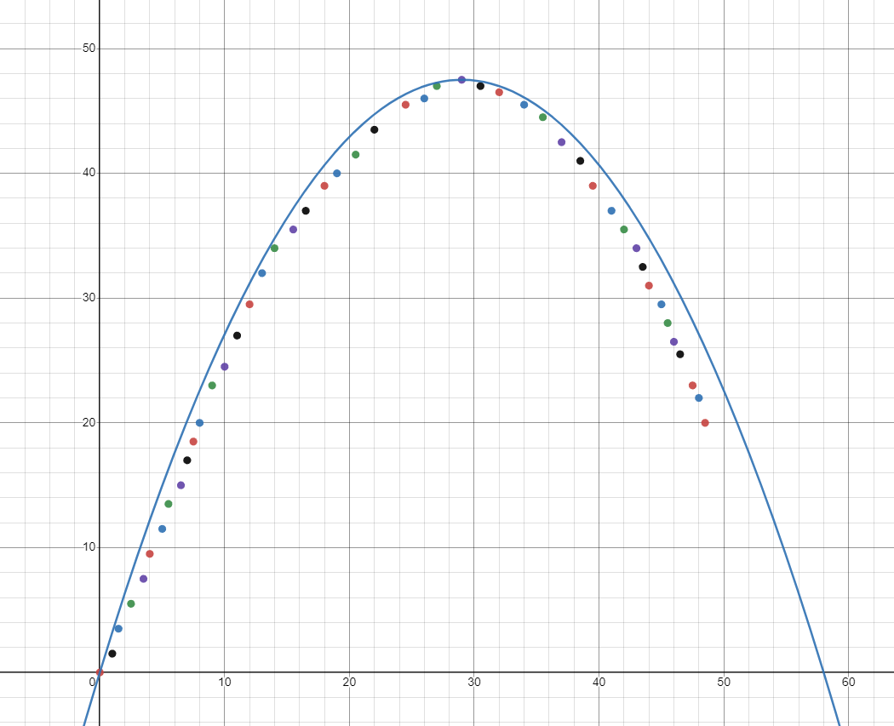**Figure 6**

In Figure 7 below it is clearly shown that the formula in Figure 4 is a possible valid solution as the parabola is calculated from the waterspout beginning point shown in Figure 1 which is prone to less abnormalities and is easy to follow before gravity takes effect. Figure 7’s validity is obtained by its parabola passing through 7 out of 47 points such as: (38.5,41) (46.5,25.5) and (18,39).

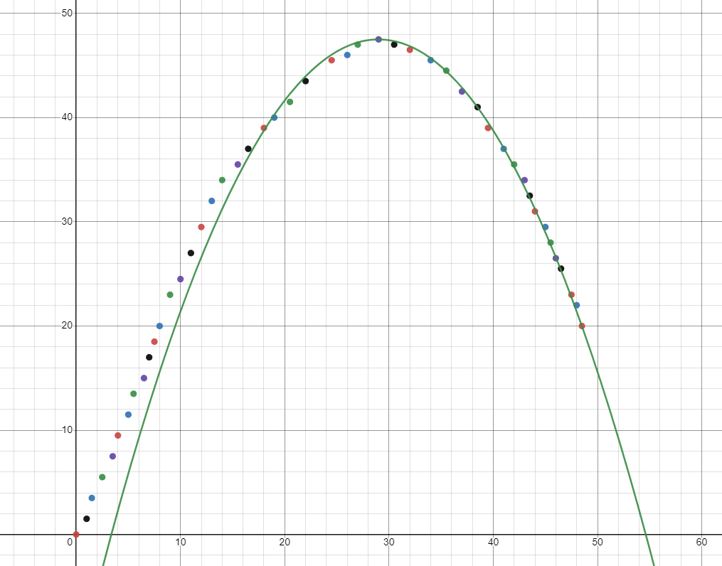**Figure 7**

The formulas calculated in Figures 3 & 4 aren’t suitable to a practical extent. Inside Microsoft Excel there is the ability to create polynomial function’s using the Figure 2 Data set and Figure 5 graph. Using the trendline function inside Excel it is possible to create a polynomial function of the orders 2 to 6. These functions can then be substituted into Desmos the same as the Formulas in Figures 3 & 4 to create parabolas.

The formula created by polynomial order 2 in Figure 8 below isn’t a valid solution. Its R2 value is low compared to the others in the data set and only passes through 4 of the 47 points

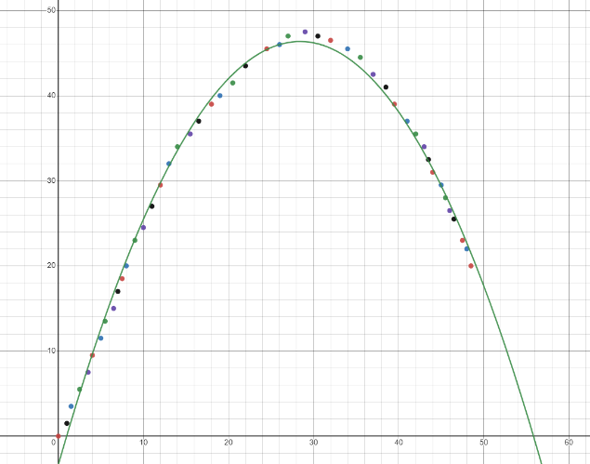**Figure 8 (Polynomial power 2)**

y = -0.06163x2 + 3.50050x - 3.36467

R² = 0.99503

The Formula created by polynomial order 3 in Figure 9 below is a valid solution as it has a high R2 value of 0.0998 and passes through 15 out of 46 points. The function shown in Figure 9 is a negative and therefore a reflection (negative) which also connects to our assumptions. Figure 9 passes through the points: (1,1.5) (8,20) (18,39) and (45,29.5).

**Figure 9 (Polynomial power 3)**

y = -0.00033x3 - 0.03731x2 + 3.04025x - 1.66830  
R² = 0.99826

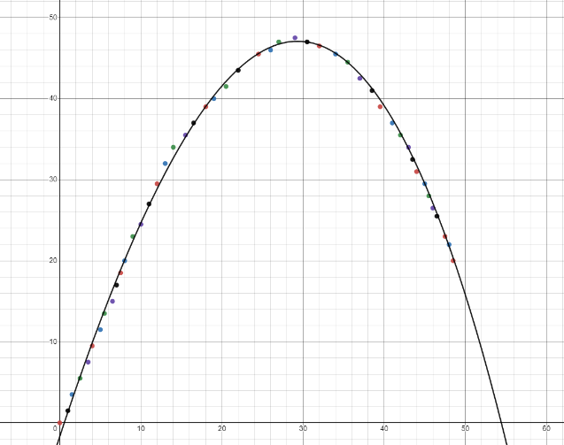

The formula created by polynomial order 4 in Figure 10 below isn’t a valid solution. Its R2 value is high but the parabola doesn’t line up with most of the data points and as shown by Figure 10 it doesn’t continue downwards forever like an actual parabola.

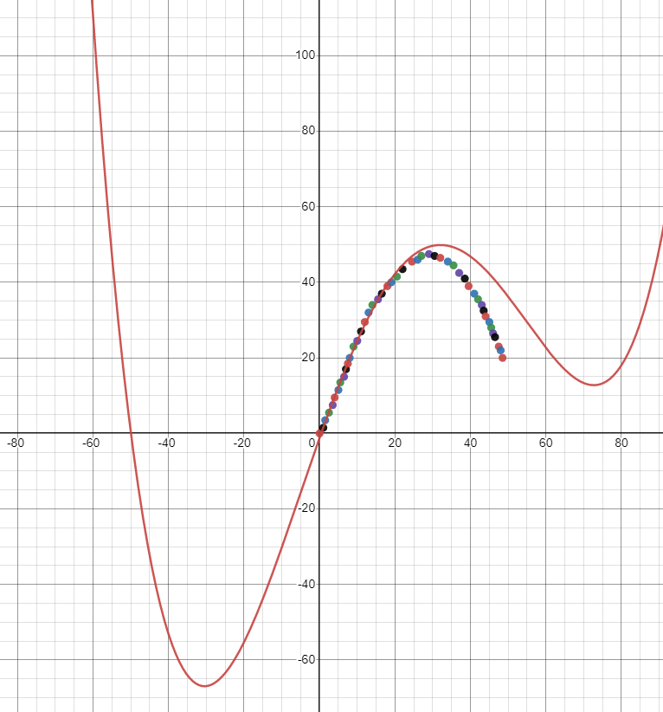**Figure 10 (Polynomial power 4)**

y = 0.00001x4 - 0.00099x3 - 0.01722x2 + 2.83435x - 1.21450  
R² = 0.99847

The formula created by polynomial order 5 in Figure 11 below isn’t a valid solution. It has a high R2 value, but the formula isn’t negative conveying it is a positive parabola which doesn’t connect with our assumptions.

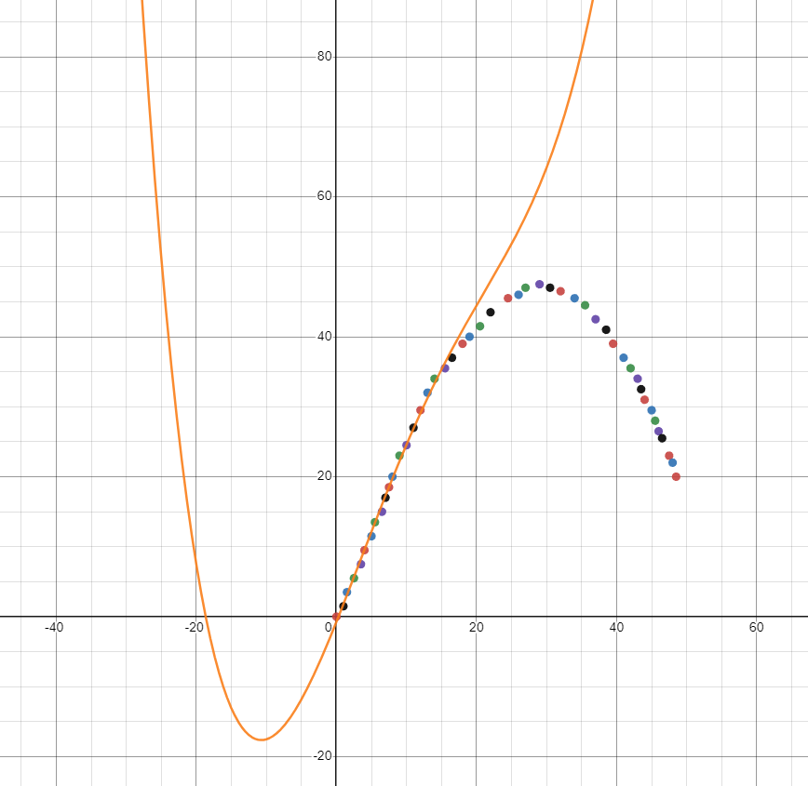**Figure 11 (Polynomial power 5)**

y = -0.00000x5 + 0.00008x4 - 0.00393x3 + 0.03473x2 + 2.49775x - 0.74022  
R² = 0.99870

The formula created by polynomial order 6 in Figure 12 below isn’t a valid solution. It also has a high R2 value but lacks the negative $a$ value and doesn’t follow parabolic features such as continuing downwards (or upwards) forever.

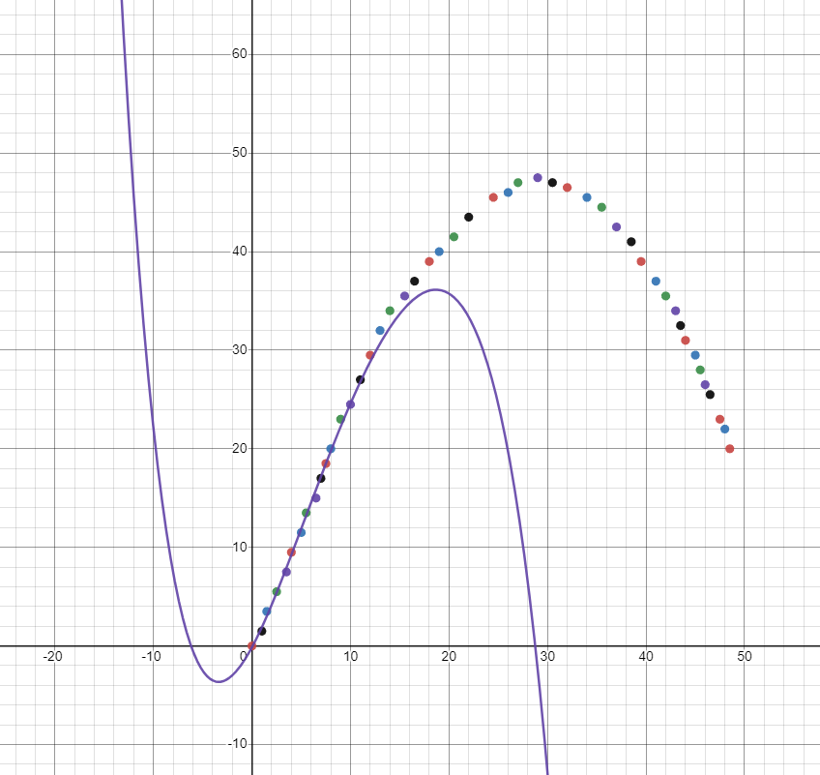**Figure 12 (Polynomial power 6)**

y = 0.00000x6 - 0.00001x5 + 0.00056x4 - 0.01629x3 + 0.17877x2 + 1.85421x - 0.13472

R² = 0.99909

**Solution:**

The aim of this investigation was to develop a function that models a waterspout that follows a reflective parabolic path. For the water bubbler in Figure 1 the most accurate formula was produced by Excel with the polynomial order 3 in Figure 9. The formula y = -0.00033x3 - 0.03731x2 + 3.04025x - 1.66830 is the most valid solution because it passes through 15 of the 47 coordinates listed in Figure 2 as well as having a high R2 value of 0.99826. These connect directly to the assumptions as the formula is negative and therefore a reflection. This solutions validity is further expanded as it follows the general shape of the data points in Figure 2 unlike the graphs in Figures 10, 11, & 12. This validates the parabola with the assumption that the R2 will never be 1 because it is practically impossible to achieve a perfect parabola in nature once the potential for error and abnormalities are calculated in. The validity of this solution is amplified with the connection to the major assumption that no external forces were affecting the waterspout, this is correct as the photo in Figure 1 was taken on a day with no wind and behind a building, removing the potential for these to affect the data. Finally, the solution is valid because the coordinates in the Figure 2 data set and Figure 5 graph are spaced evenly and with enough points to create a large sample size to reduce the potential of abnormalities and errors.

**Strengths & Limitations:**

Throughout the creation of this report, there were multiple strengths and limitations found. The strengths of this task are that the selected photo in Figure 1 was taken behind a building, limiting the potential for abnormalities stated in the assumptions. The photo was taken in a high visibility area with plenty of light to ensure the parabola was defined properly when printed. Another a factor that that adds validity to this report is the use of reliable sources and the use of the accredited software programs such as Microsoft Excel and Desmos.

Due to the shape of the parabola in Figure 1 and the selected method for graphing the data set this caused the lack of a 2nd x-intercept. This mixed with the parabola being smaller than others lead to their being only 47 total points, which reduces the total data range/ sample size. Another possible limitation is the fact that the water bubbler is plumbed into multiple others, and therefore its water pressure could change mid photo, creating an uneven parabola, affecting the plotted coordinates.

**Conclusion:**

In conclusion the task of developing an appropriate function that models a waterspout from a water bubbler was a success. Inputting the collected data set from the image allowed the creation of an accurate and appropriate function using the 3rd polynomial order. The final formula y = -0.00033x3 - 0.03731x2 + 3.04025x - 1.66830 matches the assumptions and observations that it would be a reflection. Finally, the solution generated in this report agrees to all of the set criteria for the task as well as the assumptions and observations.

**References (APA7):**

*How to find the turning point of a parabola?* (2022, April 16). GeeksforGeeks. <https://www.geeksforgeeks.org/how-to-find-the-turning-point-of-a-parabola/>

*X Intercept - Definition, Formula, How to Find, Examples*. (n.d.). Cuemath. <https://www.cuemath.com/geometry/x-intercept/>

Nau, R. (2019). *What’s a good value for R-squared?* Duke.edu. <https://people.duke.edu/~rnau/rsquared.htm>

Britannica. (2019). Gravity - Newton’s law of gravity. In *Encyclopædia Britannica*. <https://www.britannica.com/science/gravity-physics/Newtons-law-of-gravity>